- To prepare for testing adjust zero _______ of the RZ-25 tester.

- Point
- Reference
- Calibration

- A ______ exhalation or inhalation valve could be caused by a defective valve seat or valve disc.

A. Leaking
B. Perforated
C. Leaky

3. Dow _____ _____ is to be used to lubricate O-rings.

A. Molykote 111
B. Corning 111
C. Lubricant 111

- The factory packed ______ is good for 4 years from the manufacture date.
A. Canister
B. Cartridge
C. Regencanister

- The pressure relief valve is designed to open when the pressure within the breathing circuit is between ___ and ___ millimeters (+2 mbar and +5 mbar) of pressure measured on the water gage.

A. + 20, +50
B. + 25, +50
C. + 25, +55

- During testing of the inhalation valve, if valve is _______ properly, +10 mbar is indicated on the pressure gauge.

A. Sealing
B. Opening
C. Operating

- A ________cylinder is full at _____ psi when a + is stamped at hydro test.

A. Steel, 3135
B. Carbon Fiber, 3000
C. Aluminum, 3100

- A fully filled steel oxygen cylinder ____ ____ liters of medical oxygen.

A. Takes 444
B. Contains 544
C. Holds 440

- The weight of a fully ______ BG-4 apparatus is 15kg (33 lbs)

A. Filled
B. Charged
C. Operational

- Check the supply of oxygen gas on the Sentinel at intervals of approximately ___ minutes.

A. 15
B. 10
C. 20

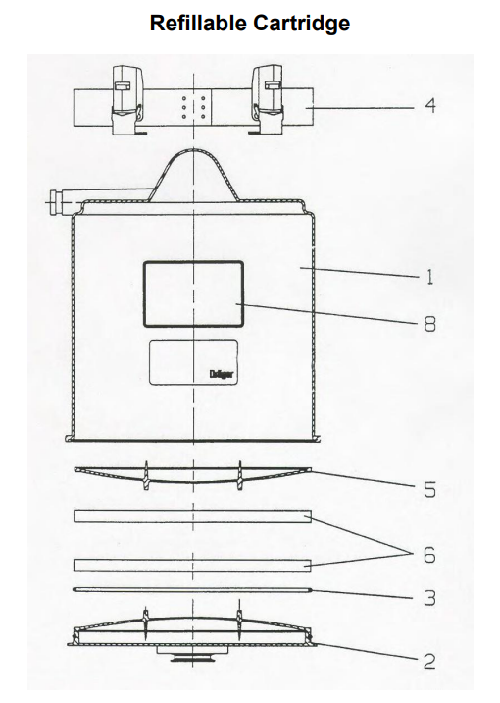

1-8 Refillable Cartridge  2 Lid  3 _____, Refillable Cartridge (11)  4 Strap with Tension Spring Hook | 5 Refillable Scrubber Screen  6 Filter ______ (12)  8 ______ Approved Label (13)

(11) (12) (13)
A. Seal A. Cushion A. Drager
B. O-Ring B. Mats B. MSHA
C. Gasket C. Pads C. NIOSH

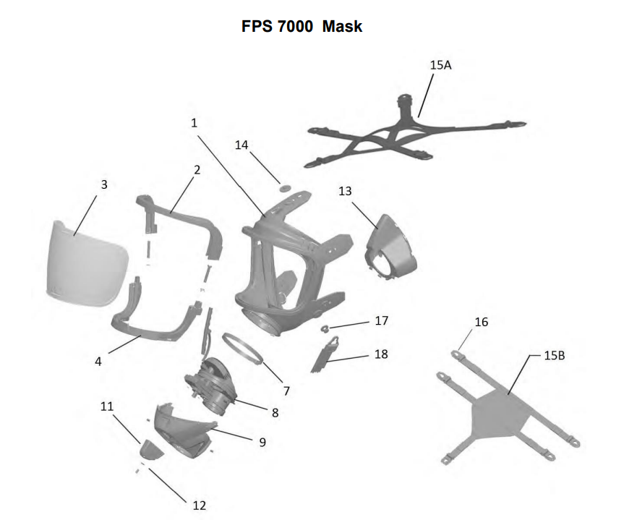

1 Mask Body FPS 7000  3 _______ (14)  7 Clamp  8 ______ _____ (15) | 14 Button  15B _______ (16)  17 ______ Button (17)  18 Neck Strap

(14) (15) (16) (17)
A. Shield A. Connector Piece A. Strap A. Double
B. Lens B. Tee Connector B. Hairnet B. Single
C. Visor C. Connecting Coupler C. Harness C. Push

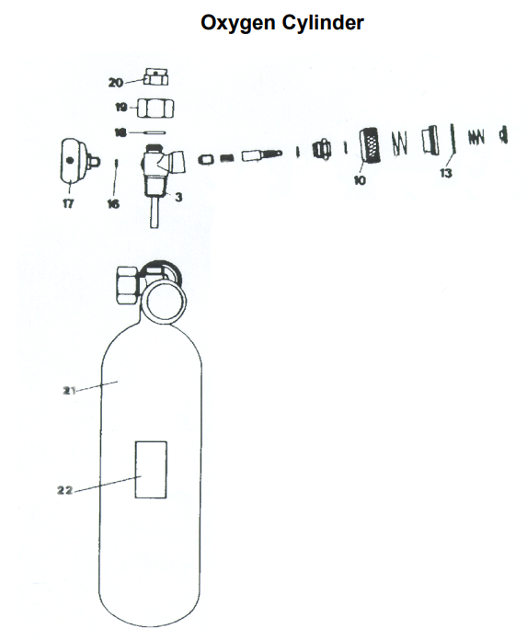
3 _______ Housing (18)  10 Hand-Wheel  13 _____ Ring (19) | 18 Lock _____ (20)  21 Oxygen Cylinder  22 Label

(18) (19) (20)
A. Pressure A. Ball A. Nut
B. Reducer B. O- B. Washer
C. Valve C. Safety C. Ring

